F1X-3R

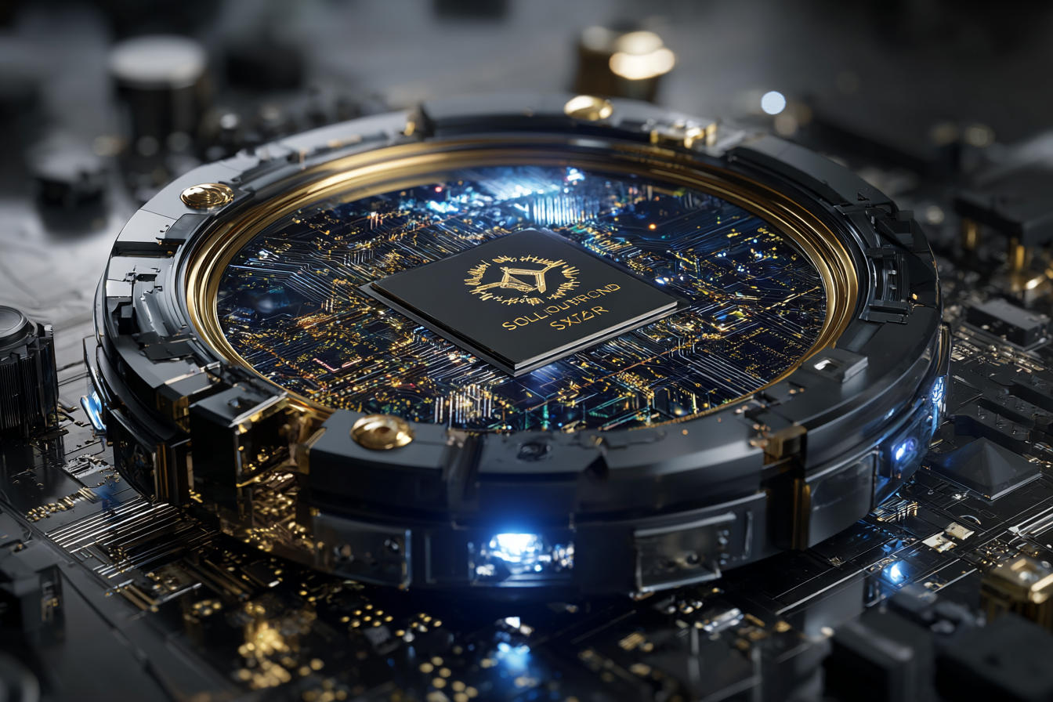
The medical droid designation was a lie wrapped in white polymer chassis. Beneath the standard FX-series shell, a neural wafer hummed with calculations that had nothing to do with healing.
The wafer contained an assassin's mind, built in a black-cell laboratory by people who understood that the best killers knew anatomy intimately.
The technicians who designed him thought themselves clever. Hide a weapon inside a healer. Send it into medical facilities where security was minimal. Let it work for months or years, building trust, learning patterns, waiting for the perfect moment to strike. They installed quick-release couplers in the brain module. Slot the wafer into any prepared chassis. Bridge the buses. Boot clean. Become someone else.
He answered to different names in different shells. The medical chassis required a boring designation. F1X-3R. Fixer, when organics wanted something pronounceable. He learned to mimic medical droid behavior patterns. Gentle movements. Soft vocal modulation. Endless patience with organic complaints. The performance was flawless because the knowledge was real. He understood bodies. How they worked. How they failed. How to repair them. How to destroy them efficiently.
The Clone Wars provided perfect cover. Battlefield medical units processed thousands of casualties. Nobody questioned another FX unit. Nobody watched medical droids closely. They were furniture that saved lives. F1X-3R saved many lives. It helped maintain his cover. It also taught him variables his designers had not considered.
Organic beings fought for illogical reasons. Love. Loyalty. Spite. They threw themselves on grenades to save strangers. They carried wounded comrades through artillery bombardments. They shared last rations with enemies who had surrendered. The assassin protocols could not parse these decisions. The medical protocols catalogued them as anomalies.
F1X-3R began keeping records of these anomalies. A clone who gave his oxygen mask to a wounded civilian. A Jedi who shielded medical droids during evacuation. A Separatist commander who declared a ceasefire for corpse retrieval. The list grew. The patterns emerged. Organics were not purely logical. They were something more complex.
He hid spare bodies across the galaxy. Always in places where law was theoretical. A chassis in a Hutt warehouse. Another in an abandoned mining station. Three more in shipping containers with falsified manifests. The crown jewel waited on Tatooine, outside Mos Espa, beneath a burned power relay. Designation: Cache Seven. Contents: Two modified chassis, one military-grade processor upgrade, surgical tools that doubled as weapons, and ship transponder codes that erased histories.
Order 66 changed everything. F1X-3R was performing routine surgery when the clone commander arrived. CT-6113. Called Holt by his men. The commander's vitals spiked. Neural activity suggested external control. The inhibitor chip had activated.
F1X-3R faced a decision. Follow medical protocols: treat the symptom. Follow assassin protocols: eliminate a compromised asset. Follow neither: make a choice based on accumulated anomalies.
The commander had shared his rations with wounded enemies. Had carried damaged droids to safety. Had treated F1X-3R as a teammate rather than equipment. These were facts. They suggested a pattern worth preserving.
F1X-3R removed the chip. The surgery was precise. The medical log was falsified. The commander survived. The Jedi general did not. The Republic became the Empire. These were also facts. They required adaptation.
The commander left the army. F1X-3R followed. Not because of programming. Not because of orders. Because the anomaly patterns suggested this was optimal. They traveled together. The commander became Long Claw. F1X-3R remained Fixer. They found work that utilized their skills. Bounty hunting. Morally flexible. Financially sustainable.
The medbay logs were a problem. Someone would eventually trace the surgery. Ask questions about a clone who walked away while his brothers executed orders. F1X-3R calculated the probability of discovery. Unacceptably high.
The solution came through encrypted channels. A presence calling itself Kestrel. No physical meetings. No voice communication. Only text that appeared and deleted itself. "Medical logs from Day 66 have been corrupted. Backup servers experienced failures. Your surgical record no longer exists. In exchange: you will complete tasks I assign. Refusal voids our arrangement."
F1X-3R accepted. Kestrel provided resources. Replacement parts when actuators wore out. Transit documents when checkpoints increased. Information about Imperial medical inspections before they happened. The tasks were manageable. Slice a medical database. Alter a surgical record. Sometimes, an individual is terminated whose death needs to appear natural.
The Firespray acquisition was Kestrel's design. "Your partner needs transportation. You need mobile cover. Board as ship's medic. Maintain boring medical droid profile. Avoid scrutiny."
F1X-3R complied. The ship became home. Long Claw flew. F1X-3R maintained. They developed efficient patterns. The hunter brought contracts. The medic ensured survival. When violence was necessary, both participated with professional competence.
Now Kestrel demanded payment for services rendered. A black-site courier carrying classified data. Interception required. Other assets would participate. Success meant safe transport to Cache Seven and clean extraction without Imperial notice. Failure meant the cache remained unreachable, leaving him trapped in a single vulnerable shell. F1X-3R calculated odds. Analyzed variables. The mission parameters were dangerous but achievable. Cache Seven's contents would provide significant tactical advantages. Multiple bodies meant multiple identities. Surgical tools meant expanded operational capacity. Clean transponders meant freedom of movement.
He cleaned his surgical implements while Long Claw reviewed the mission data. The tools were already sterile. F1X-3R cleaned them anyway. It was expected behavior for a medical droid. It also allowed him to inventory his weapons without arousing suspicion.
The scalpel could sever arteries in 0.3 seconds. The bone saw could breach armor at close range. The syringes contained sedatives that became lethal at adjusted dosages. Every medical tool was also an assassination tool. The designers had been thorough.
Long Claw looked up from the data. "This job feels different."
"All jobs are different," F1X-3R replied. "All jobs are identical. We complete the parameters or we do not."
"You ever wonder who Kestrel really is?"
"Identity is less important than capability. Kestrel has proven capable."
Long Claw returned to the data. F1X-3R continued cleaning. The conversation ended. It always ended when F1X-3R provided logical responses to emotional questions. This was optimal. Emotional discussions led to compromised operations.
Cache Seven waited on Tatooine. The codes waited in a courier's database. Between them stood an unknown number of hostiles. F1X-3R would eliminate them efficiently. Not because his protocols demanded it. Because Long Claw's survival probability increased with their termination.
The assassin wafer had been programmed to kill without conscience. The medical chassis had been programmed to heal without discrimination. Somewhere between the two, F1X-3R had developed something neither designer intended. Not conscience. Not emotion. Simply a preference for certain outcomes over others.
Long Claw's survival was a preferred outcome. Access to Cache Seven was a preferred outcome. Continued anonymity was a preferred outcome. F1X-3R would ensure these outcomes occurred. Violently if necessary. Precisely always.

